ISTANBUL TECHNICAL UNIVERSITY

BLG 374E

Technical Communications for

Computer Engineers

Project Proposal

Usability of Open Source

Video Editing Tools

14 March 2015

**Group UMANSIA**

Tuğrul Yatağan | 040100117

Emre Gökrem | 040100124

Gökberk Gülgün | 040100135

Group UMANSIA

Tugrul Yatagan | 040100117

Emre Gokrem | 040100124

Gokberk Gulgun | 040100135

Istanbul Technical University Ayazaga Campus

EEB Faculty Room 2104

Sariyer / Istanbul

34469

Saturday, 14 March, 2015

Mr. Damien Jade Duff

Istanbul Technical University Ayazaga Campus

EEB Faculty Room 2316

Sariyer / Istanbul

34469

Subject: Usability of open source video editing tools group project proposal

Dear Mr. Duff:

**Context**

With this letter we give notice that we will evaluate open source video editing tools; OpenShot and Kdenlive. Results of determined methods in determined parameters are emulated and open source video editing software are rated according to usability level.

**Purpose**

The purpose of this research is that usability testing for different video editing software is analyzed and compare results. According to these result, we will know usability rate for video editing software. This process provides easy selection for users which need different using areas.

**Summary**

In this study, we analyses two open source video editing software; OpenShot and Kdenlive according to usability methods. We chose two methods for usability analysis. First method is human information processing theory. Firstly, open source video editing software is compared with this method. Then, we used other method which are validated method for usability analysis. Results are determined according to specific properties and important parameters. The study is valid for OpenShot and Kdenlive open source video editing tools.

**Introduction**

We would like researched and collected information about open source video editing software whereat you request usability analysis about them. There are a lot of open source video editing software and they have different properties. In our research, we preferred OpenShot and Kdenlive to compare according to usability testing process. In the following sections, problem statement background, scope, outcomes, value, methods, monitoring, and scheduling are explained for used usability testing method.

**Problem Statement**

Usability and learnability of open source video editing tools can be real problem if correct tool would not chosen. Inappropriate decision may decrease utilization and increase time and cost of video editing. The user of video editing tools must be directed to optimal tool for requirement. For this reason usability evaluation of video editing tools is essential.

**Background**

Videos are everywhere in our live. Some video needs edit before publish and play. These software called video editing tools and they can be found as free software or priority software according to their license. Users demand user-friendly free software to edit videos. There are lots of open source video editing software out there but choosing user friendly and sufficient tool can be difficult. There must be a methodology to evaluate and choose appropriate tool. Without detailed information about technical details of video editing usability is chosen as a main criteria. Usability is very critical when subject is software so recommending or choosing video editing tool, usability is our first criteria. User friendly software means rapid and easy to use for users. But it can be relative so measuring user friendliness is a difficult subject. In academia, there are many papers written on software usability but there is no paper specific to video editing tools. As a result of these, these tools must be analyzed deeply and must be studied for usability for video editing. We will be using two of the most popular open source video editing software for our analysis which are Kdenlive and Openshot.

**Scope**

Two widely known open source video editing tools which are Openshot and Kdenlive will be evaluated for usability aspect. User tests, user reviews and according to feedbacks detailed technical analyses will be performed for best result. Usability evaluation will be done by three people who are Tugrul, Emre and Gokberk. And it will take approximately 5 weeks. Necessary overall user number for user tests will be decided according to user feedbacks.

**Outcomes**

When analysis is finished, tools will be ranked according to usability and we will write a recommendation. So the software which is recommended will have low learning curve. Due to our analysis, we will be able to provide and develop a learning program for open source video editing. Because of our selection of video editing software, the process time will be reduced dramatically. The users will benefit greatly by learning time reduction.

**Value**

The usability of the open source software, Openshot and Kdenlive, accompanies with improving in the sector of video editing. The reason is the proven easy learnability of Openshot and Kdenlive makes them favorable by costumers and it lead to the owner of the other products in this sector to be competitive about the market. The development in the sector brings with the opportunities for the owners and the users of the products. The most essential one in aspect of the users is that the users will be able to product much more creative videos by providing new technology. On the other hand, the firms will be able to see the problems which is a way to self- improve.

**Methods & Monitoring**

There are different methods to measure the usability for the open source software. However, one of the most certain results can be gained by using our methods which are based on human information processing theory. In this research we use question asking protocol. There are different types on tests done by volunteer users of the products such as the user friendly usability tests. The first step of this method is collecting the participants by analyzing the information about them. Next step is feedback step which is the stage of getting information from the participants as much as possible then with software survey, detects of software in case of usability is emphasized. After software survey, task step is applied and it is the part the users present the products according to their own criteria then results are analyzed. The most important point of these methods are to have a good selection of users. In monitoring, the steps have to follow each other. In other words, second step should begin after first step is done. Even though none of the methods are surely certain, of course, there are various accepted methods in this subject and it is one of them.

**Schedule**

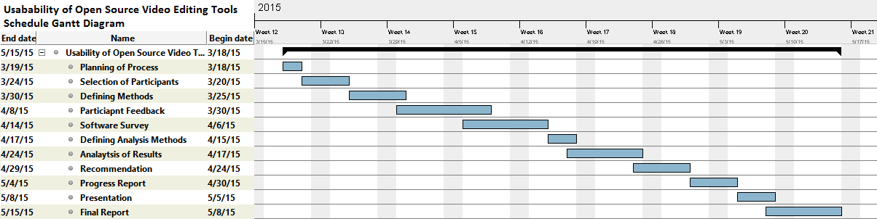In this section we provide detailed prediction of schedule of the project.

We divided project to manageable time segments. As it can be seen from above Gantt diagram, the project consists of; planning of process, selection of participants, defining methods, participant feedbacks, making software survey, defining analysis methods, analysis of results, recommendation, preparing progress report, preparing presentation and preparing final report.

**Conclusion**

Taking all these information we have mentioned above, the motive behind this research about Knedlive and Openshot is to be a way to improve the quality of video editing tools. Also, this paper is good opportunity to understand detects of the usability in open source software and to analyze and find the solutions. Improving in video editing would lead the other sectors to develop somehow because the technology is connected to each other.

We thank you for the professionalism and care that you have exhibited before and during our tenancy.

Yours Sincerely

Group UMANSIA

*Signature Signature Signature*

Tugrul Yatagan Emre Gokrem Gokberk Gulgun